
LAB TASKS ASSIGNMENT
PROGRAMMING FUNDAMENTALS

APRIL 24, 2026

Name: Karim Bux
Father’s Name: Allah Bux
Caste: Junejo
Roll Number: 2K26/AI/51
Subject: Programming Fundamentals
Teacher: Yasir Nawaz Memon
Degree: Bachelors of Artificial Intelligence
Batch: 2026

Institute of Mathematics and Computer Science,
University of Sindh, Jam Shoro.
LAB. TASK LIST #1

Task No. 1) Write a program that takes an integer number input and prints cube of that number.

Sample Output:
Enter a number: 5
Cube of 5 is: 125

#include<stdio.h>
void main()
{
printf("Enter a number: ");
int cube;
scanf("%d",&cube);
printf("Cube of %d is: %d",cube,(cube*cube*cube));
}

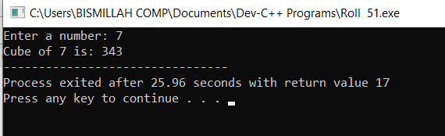
Task No. 2) Write a program that takes an ASCII code (in the range of 0 to 255) as input and prints the character which is the representation of given ASCII code.

Sample Output:
Enter an ASCII code: 67
67 is ASCII code of: C

#include<stdio.h>
void main()
{
int ascii;
printf("Enter an ASCII code: ");
scanf("%d",&ascii);
printf("%d is ASCII code of: %c",ascii,ascii);
}

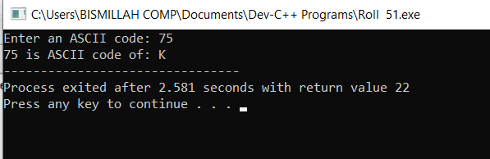
Task No. 3) Ahmed’s basic salary is input through the keyboard. His conveyance allowance is 20% of basic salary, house rent allowance is 40% of basic salary and loan installment is Rs. 1000/-. Write a program to calculate his gross and net salary.

#include<stdio.h>
void main()
{
float basic_salary, gross_salary, net_salary, housing_allowance, bonus_amount, loan_installment=1000;
printf("Enter basic pay: Rs = ");
scanf("%f",&basic_salary);

housing_allowance=basic_salary*0.4;
bonus_amount=basic_salary*0.2;
gross_salary=basic_salary+housing_allowance+bonus_amount;
net_salary=gross_salary-loan_installment;
{
printf("%.1f is gross pay\n",gross_salary);
printf("%.1f is net pay\n",net_salary);
printf("%.1f is house allowance\n",housing_allowance);
printf("%.1f is bonus amount\n",bonus_amount);
}
}

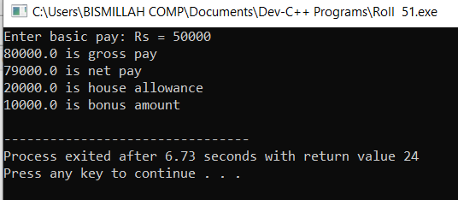
Task No. 4) The distance between two cities (in km.) is input through the keyboard. Write a program to convert and print this distance in meters, feet, inches and centimeters.

#include<stdio.h>
void main()
{
int kilometers, meters, centimeters;
printf("Enter distance in Kilometres: ");
scanf("%d",&kilometers);

float feet,inches;

meters=kilometers*1000;
centimeters=meters*100;
feet=kilometers*3280.84;
inches=feet*12;
{
printf("\nThe total distance is: %d Kilometres\n",kilometers);
printf("The total distance is: %d Metres\n",meters);
printf("The total distance is: %d Centimetres\n",centimeters);
printf("The total distance is: %.2f Feet\n",feet);
printf("The total distance is: %.2f Inches\n",inches);
}
}

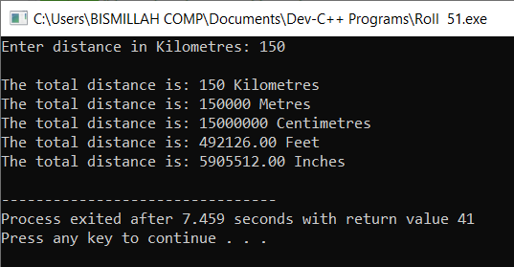
Task No. 5) Write a program that takes width and length of a rectangle and then calculate and display the area and perimeter of the rectangle.

Sample Output:
Enter width of the rectangle: 10
Enter length of the rectangle: 5
Area of rectangle having width 10 and length 5 is:
Perimeter of rectangle having width 10 and length 5 is:

Hint: Area of rectangle = length x width and Perimeter of rectangle = 2 (length + width)

#include<stdio.h>
void main()
{
int width, length, area, perimeter;
printf("Enter width of the rectangle: ");
scanf("%d",&width);
printf("Enter length of the rectangle: ");
scanf("%d",&length);

area = width*length;
perimeter = 2*(width+length);

printf("Area of rectangle having width %d and length %d is: %d\n",width,length,area);
printf("perimeter of rectangle having width %d and length %d is: %d",width,length,perimeter);
}

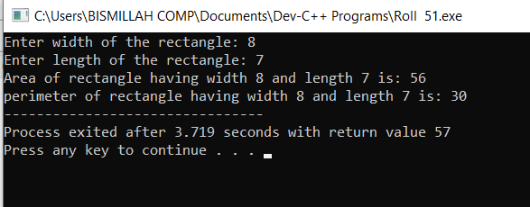
Task No. 6) Write a program that takes temperature in Fahrenheit and converts it in Celsius degree and display it on screen.

Sample Output:
Enter temperature in Fahrenheit : 67
67.00 Fahrenheit = 19.44 Celsius

Hint: Formula (32°F – 32) × 5/9 = 0°C
Note: 32°F = 0°C

#include<stdio.h>
void main()
{
float fahrenheit, celsius;
printf("Enter temperature in Fahrenheit: ");
scanf("%f",&fahrenheit);

celsius=(fahrenheit-32)*5/9;

printf("%.2f Fahrenheit = %.2f Celsius",fahrenheit,celsius);
}

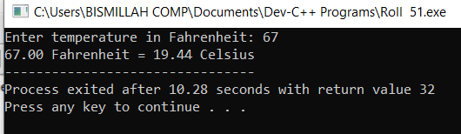
LAB. TASK LIST #2

Task No. 1) If the marks obtained by a student in five different subjects are input through the keyboard, find out the aggregate marks, percentage and grade obtained by the student. Assume that the maximum marks that can be obtained by a student in each subject is 100

#include <stdio.h>
void main()
{
int sub1, sub2, sub3, sub4, sub5;
printf("Enter obtained marks of all subjects: ");
scanf("%d %d %d %d %d",&sub1,&sub2,&sub3,&sub4,&sub5);
{
if(sub1>100 && sub2>100 && sub3>100 && sub4>100 && sub5>100);
printf("\nYou obtained %d marks out of 500\n",sub1+sub2+sub3+sub4+sub5);
printf("Your obtained percentage is %d\n",(sub1+sub2+sub3+sub4+sub5)/5);
if((sub1+sub2+sub3+sub4+sub5)/5>=90)
printf("A1 Grade");
else if((sub1+sub2+sub3+sub4+sub5)/5>=80)
printf("A Grade");
else if((sub1+sub2+sub3+sub4+sub5)/5>=70)
printf("B Grade");
else if((sub1+sub2+sub3+sub4+sub5)/5>=60)
printf("C Grade");
else if((sub1+sub2+sub3+sub4+sub5)/5>=50)
printf("D Grade");
else
printf("You're Fail");
}
}
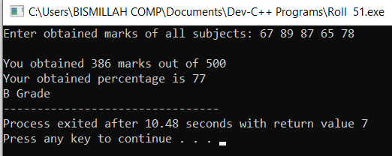
Task No. 2) Any character is entered through the keyboard, write a program to determine whether the character entered is a capital letter, a small case letter, a digit or a special symbol.

#include <stdio.h>
void main()
{
char ASCII;
printf("Enter Character: ");
scanf("%c",&ASCII);

if(ASCII>=65 && ASCII<=90)
printf("It is a Capital Letter");

else if (ASCII>=97 && ASCII<=122)
printf("It is a Small Case Letter");

else if (ASCII>=48 && ASCII<=57)
printf("It is a Digit");

else
printf("It is a Special Symbol");
}

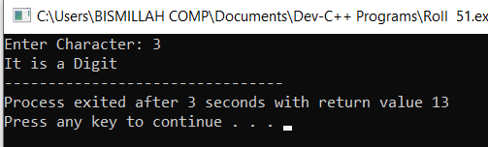
Task No. 3) A library charges a fine for every book returned late. For first 5 days the fine is Rs. 5, for 6-10 days fine is Rs. 10 and above 10 days fine is Rs. 25. If you return the book after 30 days your membership will be cancelled. Write a program to accept the number of days the member is late to return the book and display the fine or the appropriate message.

#include <stdio.h>
void main()
{
int days;
printf("Enter number of days: ");
scanf("%d",&days);

if(days<6)
printf("Your fine is 5 Rupees");

else if(days<11)
printf("Your fine is 10 Rupees");

else if(days<31)
printf("Your fine is 25 Rupees");

else if(days>30)
printf("Your no longer a member");
}

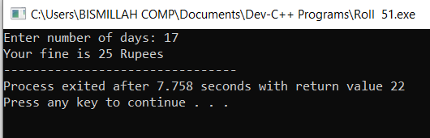
Task No. 4) Any year is input through the keyboard. Write a program to determine whether the year is a leap year or not. (Hint: Use the % (modulus) operator)

#include<stdio.h>
void main()
{
int leap_year;
printf("Enter year: ");
scanf("%d",&leap_year);

if(leap_year % 4 == 0)
printf("%d is a leap year",leap_year);

else
printf("%d is not a leap year",leap_year);
}

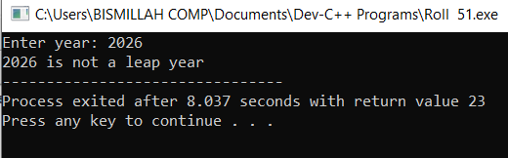
Task No. 5) If the ages of three brothers are input through the keyboard, write a program to determine the youngest of the three using nested if() statement without using logical operators.

#include<stdio.h>
void main()
{
int bro1,bro2,bro3;
printf("Enter age three brothers: ");
scanf("%d %d %d",&bro1,&bro2,&bro3);

if(bro1<bro2)
if(bro1<bro3)
printf("%d is the youngest brother",bro1);
else
printf("%d is the youngest brother",bro3);

else if(bro2<bro3)
printf("%d is the youngest brother",bro2);
else
printf("%d is the youngest brother",bro3);
}

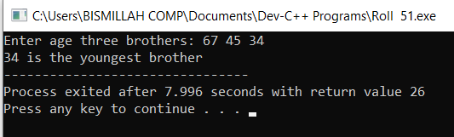
Task No. 6) If the ages of three brothers are input through the keyboard, write a program to determine the eldest of the three using logical operators.

#include<stdio.h>
void main()
{
int bro1,bro2,bro3;
printf("Enter age three brothers: ");
scanf("%d %d %d",&bro1,&bro2,&bro3);

if(bro1>bro2 && bro1>bro3)
printf("%d is the eldest brother",bro1);
else if(bro2>bro1 && bro2>bro3)
printf("%d is the eldest brother",bro2);
else
printf("%d is the eldest brother",bro3);
}

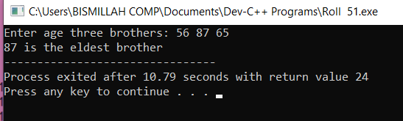
Task No. 7) Any character is entered through the keyboard, write a program to determine whether the character entered is a vowel or consonant.

#include <stdio.h>
void main()
{
char alphabet;
printf("Enter alphabet: ");
scanf("%c",&alphabet);

if(alphabet == 'a' || alphabet == 'e' || alphabet == 'i' || alphabet == 'o' || alphabet == 'u' || alphabet == 'A' || alphabet == 'E' || alphabet == 'I' || alphabet == 'O' || alphabet == 'U' )
{
printf("It is a Vowel");
}

else
{
printf("It is a Consonant");
}
}

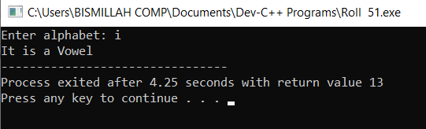
LAB. TASK LIST #3

Task No. 1) Write a program to generate the table of given number input through the keyboard.

Enter any table number: 5
Table of 5
=========
5 x 1 = 5
..
..
5 x 10 = 50

#include<stdio.h>
void main()
{
int table, loop;
printf("Enter any table number: ");
scanf("%d",&table);
printf("Table of %d\n",table);
printf("==========\n");

for(loop=1; loop<=12; loop++)
printf("%d x %d = %d\n",table,loop,(table*loop));
}
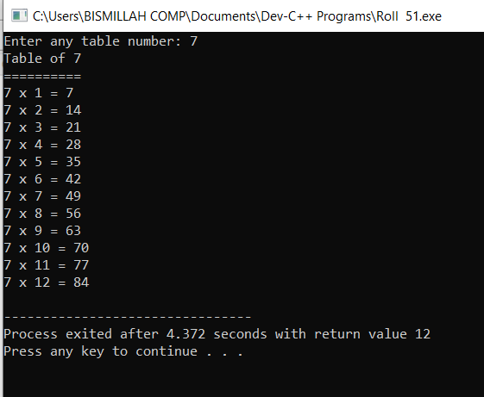
Task No. 2) Write a program to generate the following series. The output should look like as given below:

1, 27, 125, 343, 729, 1331, 2197, 3375, 4913, 6859,

#include<stdio.h>
void main()
{
int cubes;
for(cubes=1; cubes<=19; cubes=cubes+2)
printf("%d, ",(cubes*cubes*cubes));
}

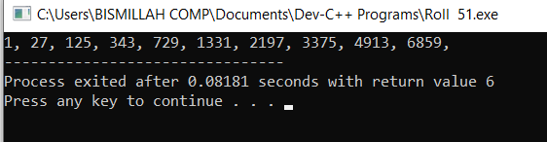
Task No. 3) Write a program to fill the entire screen with an asterisk (*) character.

#include<stdio.h>
void main()
{
int star;
for(star=1; star<=11000; star++)
printf("*");
}

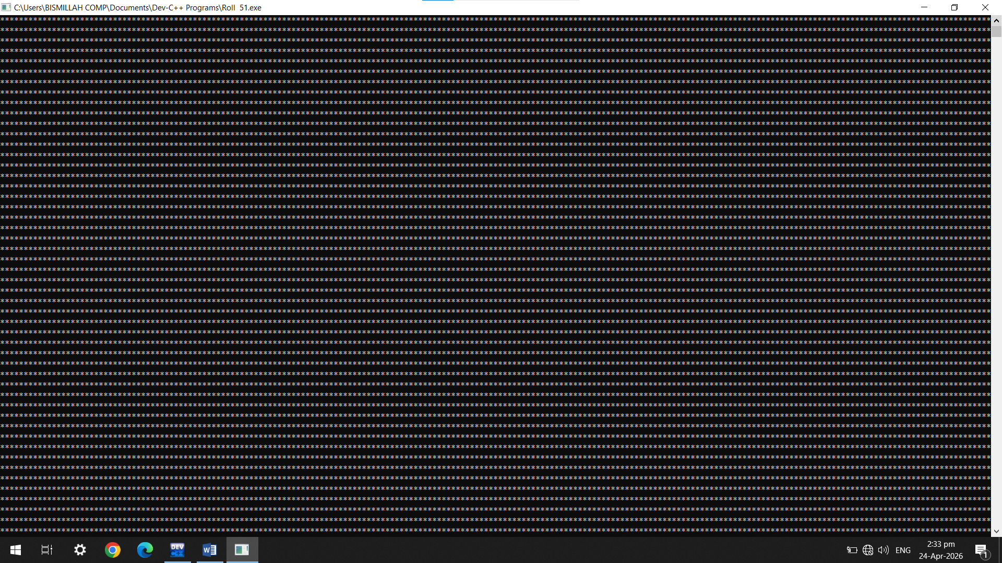
Task No. 5) Write a program that gets 10 numbers as input from the user and calculates and displays their SUM and AVERAGE on screen.

#include <stdio.h>
int main() {
int num, i, sum = 0;
float avg;
for(i = 1; i <= 10; i++) {
printf("Enter number %d: ", i);
scanf("%d", &num);
sum += num;
}
avg = sum / 10.0;
printf("\nSUM = %d\n", sum);
printf("AVERAGE = %.2f", avg);
return 0;
}

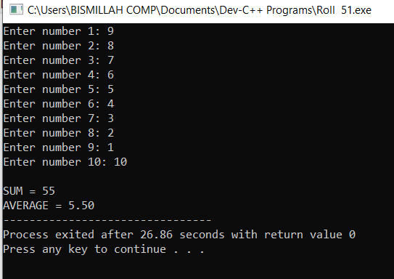
Task No. 6) Write a program to generate the Fibonacci series. The output should look like as given below:

1, 1, 2, 3, 5, 8, 13, 21, 34, 55, 89, 144,

#include <stdio.h>
int main() {
int n = 12, i;
int t1 = 1, t2 = 1, next;
printf("%d, %d, ", t1, t2);
for(i = 3; i <= n; i++) {
next = t1 + t2;
printf("%d, ", next);
t1 = t2;
t2 = next;
}
return 0;
}

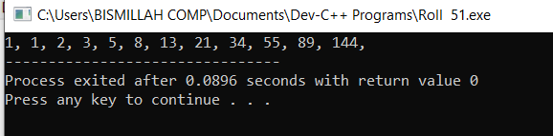
Task No. 7) Two numbers are entered through the keyboard. Write a program to find the value of one number raised to the power of another. You are not allowed to use pow() built in function.

Enter base: 3
Enter power: 4
Result is (3 ^ 4) => 81

#include <stdio.h>
int main() {
int base, exp, i, result = 1;
printf("Enter base: ");
scanf("%d", &base);
printf("Enter power: ");
scanf("%d", &exp);
for(i = 1; i <= exp; i++)
result *= base;
printf("Result is (%d ^ %d) => %d", base, exp, result);
return 0;
}

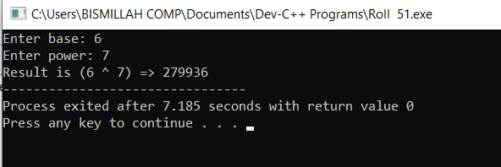
Task No. 8) Write a program to find the factorial value of any number entered through the keyboard.

Enter any number: 5
Factorial of 5 is: 120

#include <stdio.h>
int main() {
int n, i;
long fact = 1;
printf("Enter any number: ");
scanf("%d", &n);
for(i = 1; i <= n; i++)
fact *= i;
printf("Factorial of %d is: %ld", n, fact);
return 0;
}

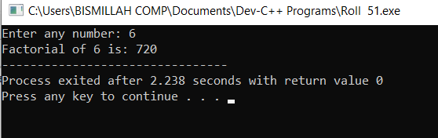

THE END

